Construct is run when the class is instantiated.

Access control prevent from the creating, updating and deleting the post from the guest.

Without access control guest can create , update and delete the post

So we will use the middleware functionality

Everything is blocked if the user is not authendticated(means usernameand password ). if we use the middleware functionality

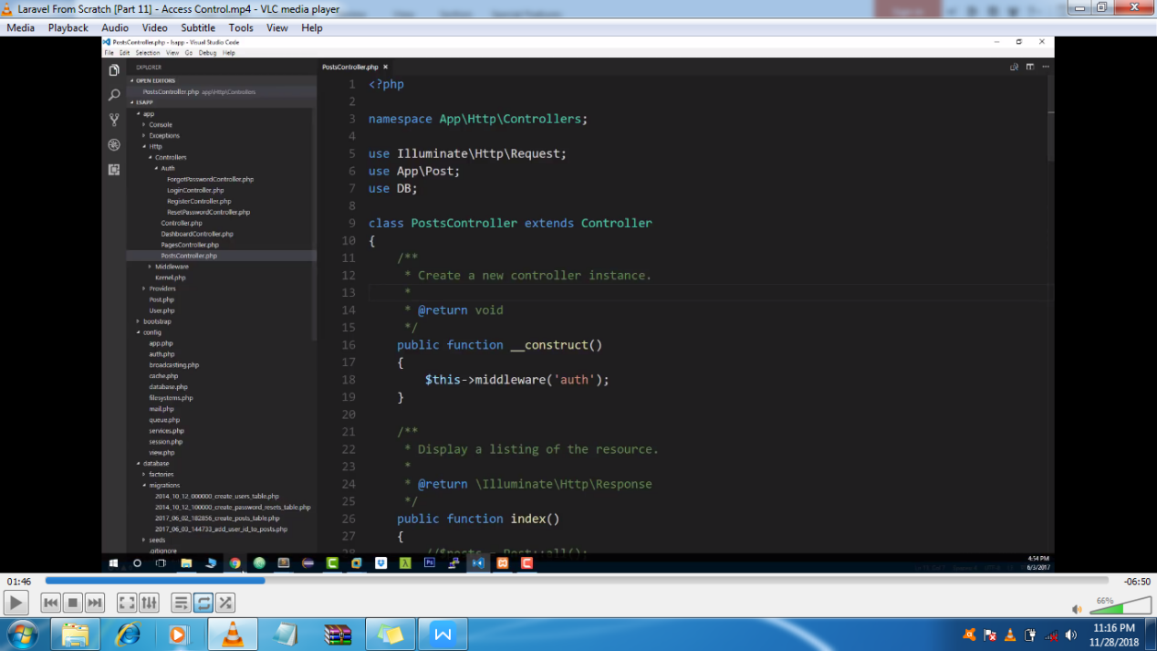

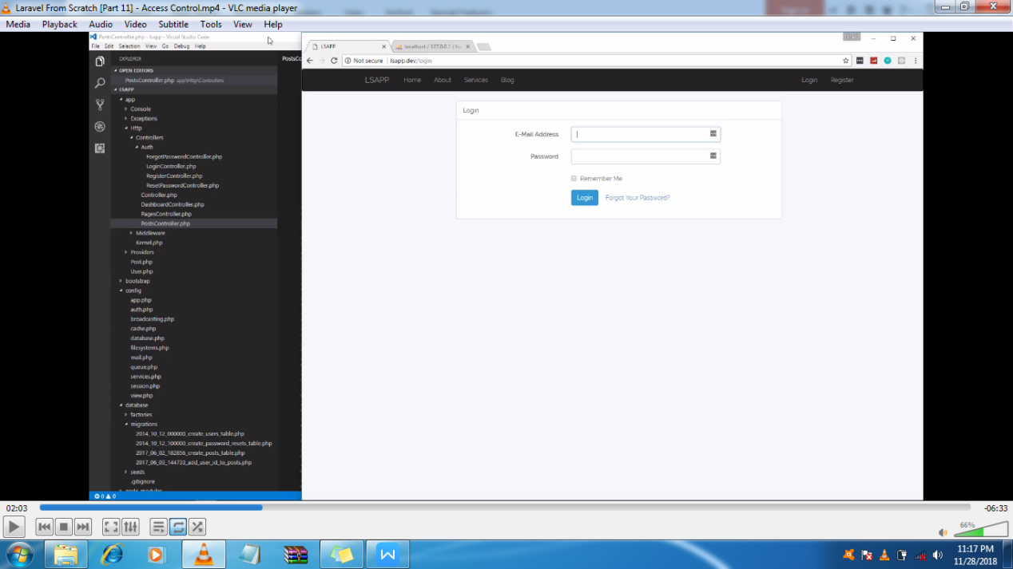

For that we will include the middleware

So we will paste the constructor in our controller but it will block everything to show the post we will use the exception.

But we will also add the exception in that

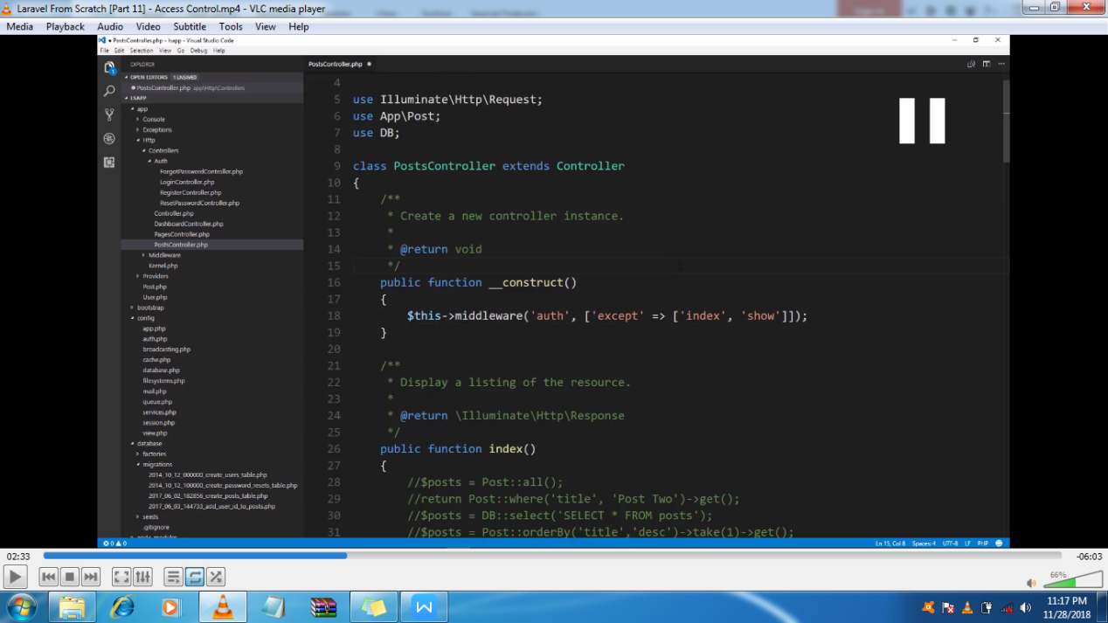

1:18

If we don’t then it will not show any record

2:18

Here we wont be able to delete, edit or create any post but also we want not to show any button

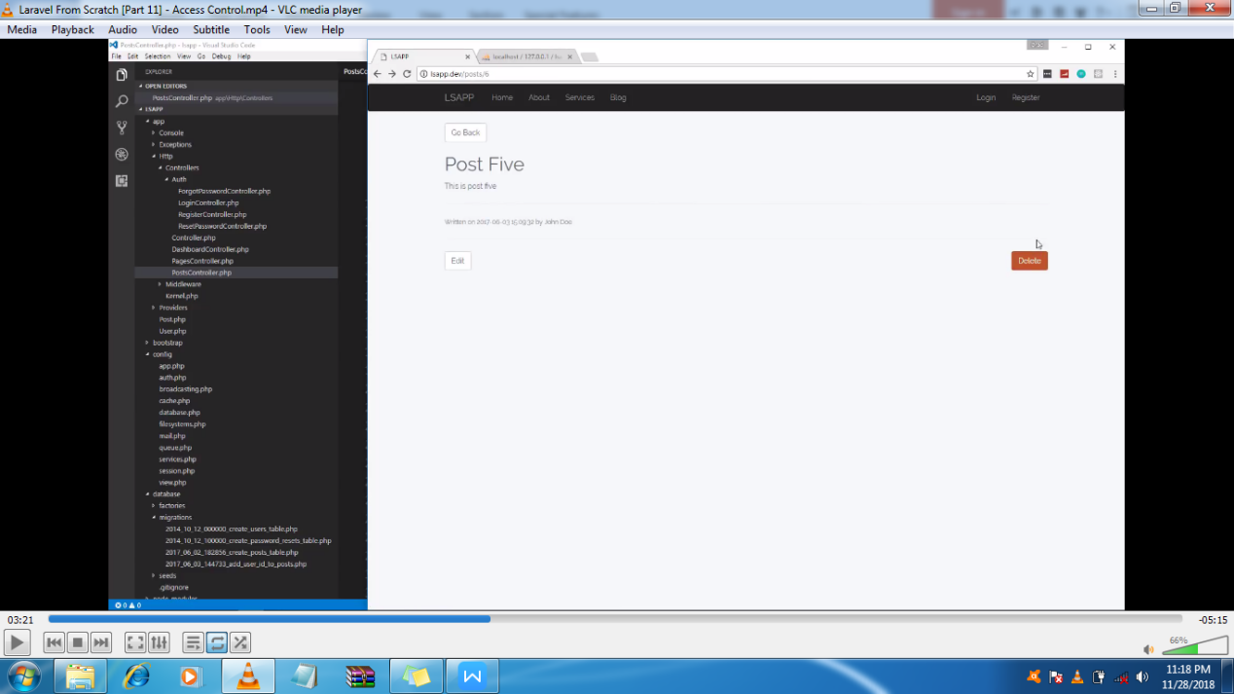

/Here we are checking if the user is not a guest in the post then it can delete the post

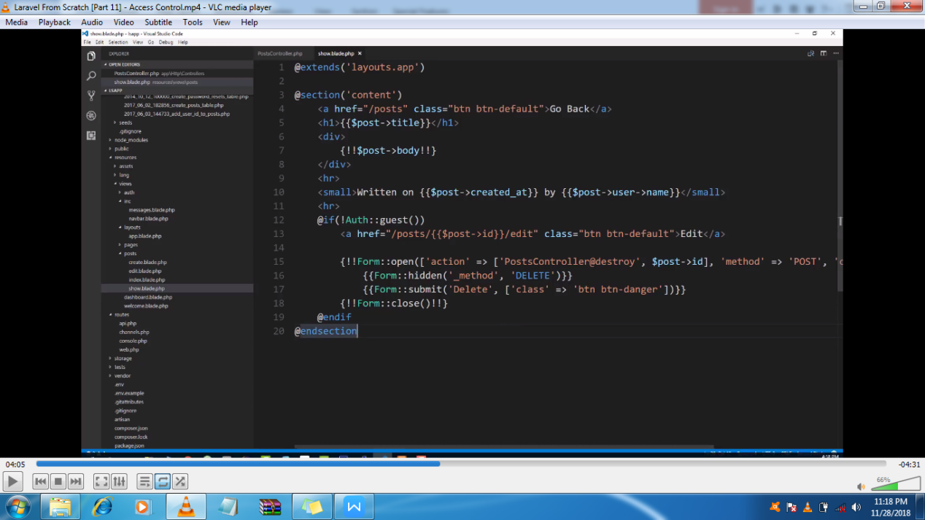

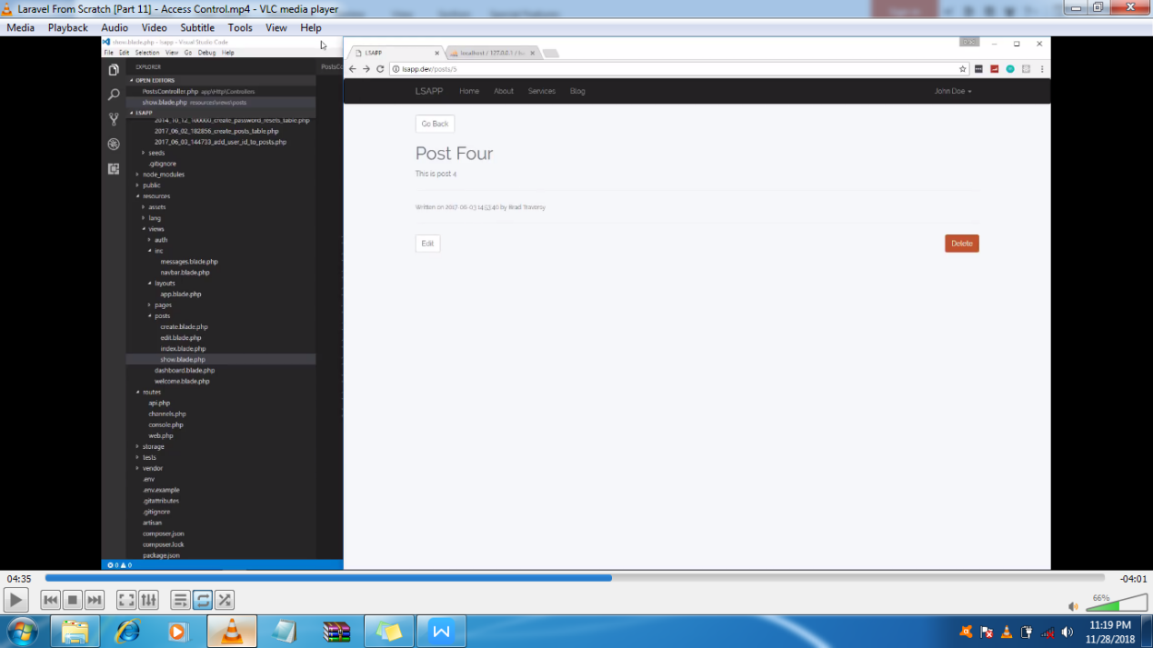

/we also want the useres created their post can only delete their post. Here we will match the post user_id to the users id

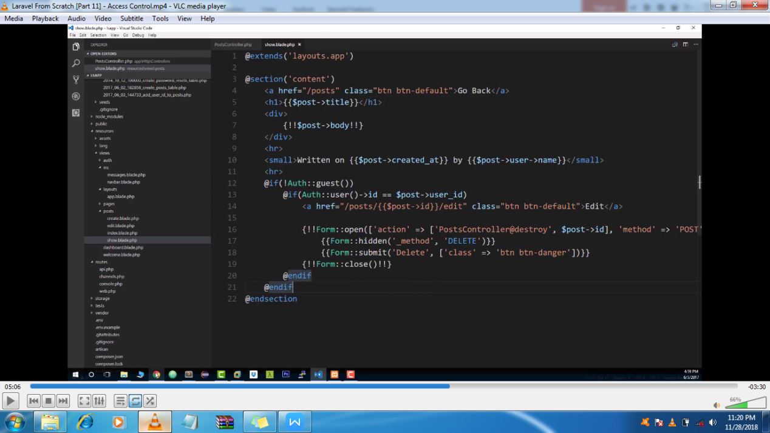

// but here if we manually go the url then still we can edit the post but we don’t want that.

For that we will go the postController

In edit method

Here we will check the correct user id

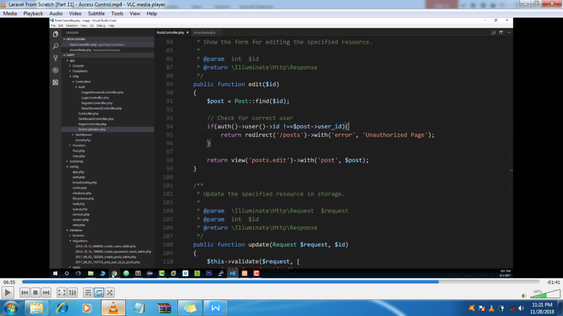

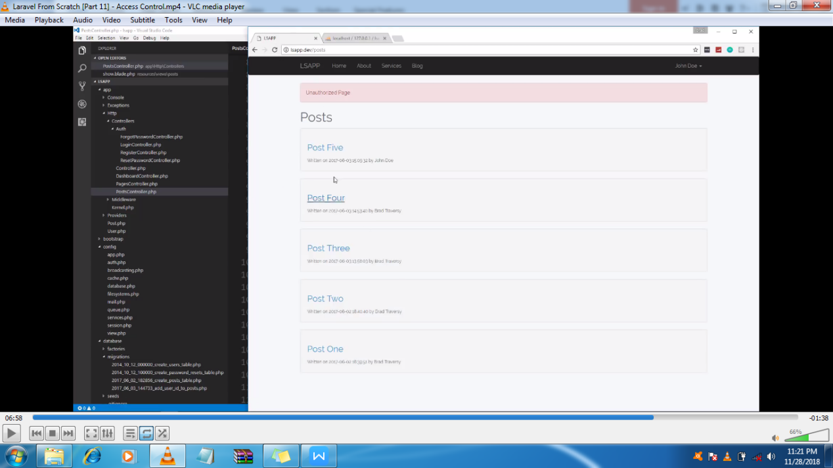

Now we will do the same thing for the delete

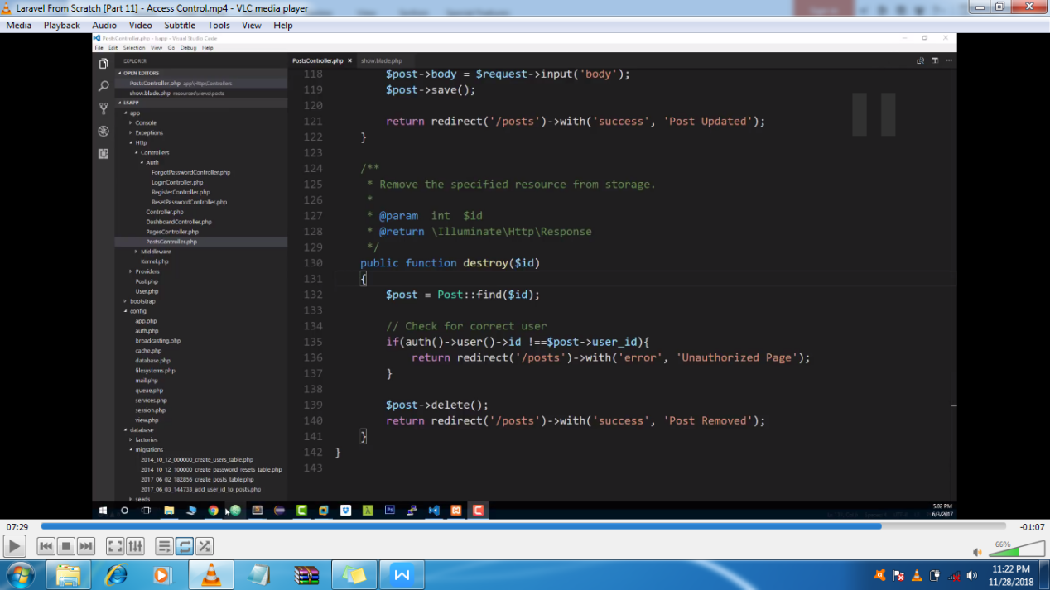

In our posts